Project Design Phase
Solution Architecture
Date | 22 September 2026
Team ID | SWTID-2026-2748
Project Name | AI BlogNest API
Maximum Marks | 4 Marks

Solution Architecture: BlogNest
Solution architecture for BlogNest bridges the blogging requirements with the software components that implement them. The architecture defines how users, the client interface, API routes, controller workflows, security controls, database, AI services and comment moderation work together.

Goals of the BlogNest Solution Architecture
- Provide a structured technology solution for creating, managing and publishing blog content.
- Describe the structure, characteristics and behaviour of the BlogNest software to project stakeholders.
- Define the main features, development components and technical requirements.
- Provide a clear specification for managing users, posts, comments, tags, security and AI-assisted content services.

BlogNest Architecture Components
Component | Main Responsibility | BlogNest Implementation
Users & Roles | Controls who can perform each operation. | Admin, Editor, Author and Reader roles with role-based access.
Frontend / Client | Provides the user-facing interaction layer. | Authentication, blog dashboard, post management and comment interaction.
API Routing Layer | Connects incoming requests to application logic. | REST endpoints and headless API routing.
Controller Layer | Processes requests and executes business workflows. | Validation, CRUD workflows and JSON responses.
Security & Authentication | Protects routes and user-provided input. | Token processing, route guards and sanitization.
MongoDB + Mongoose | Stores and models application data. | Users, posts, comments, tags and content status.
AI Services | Supports content creation and summarization. | LLM-based blog generation, summaries, abstracts and metadata.
Content Moderation | Controls comment and publishing states. | Approved, pending and spam moderation workflow.

Figure 1: BlogNest Solution Architecture and Data Flow
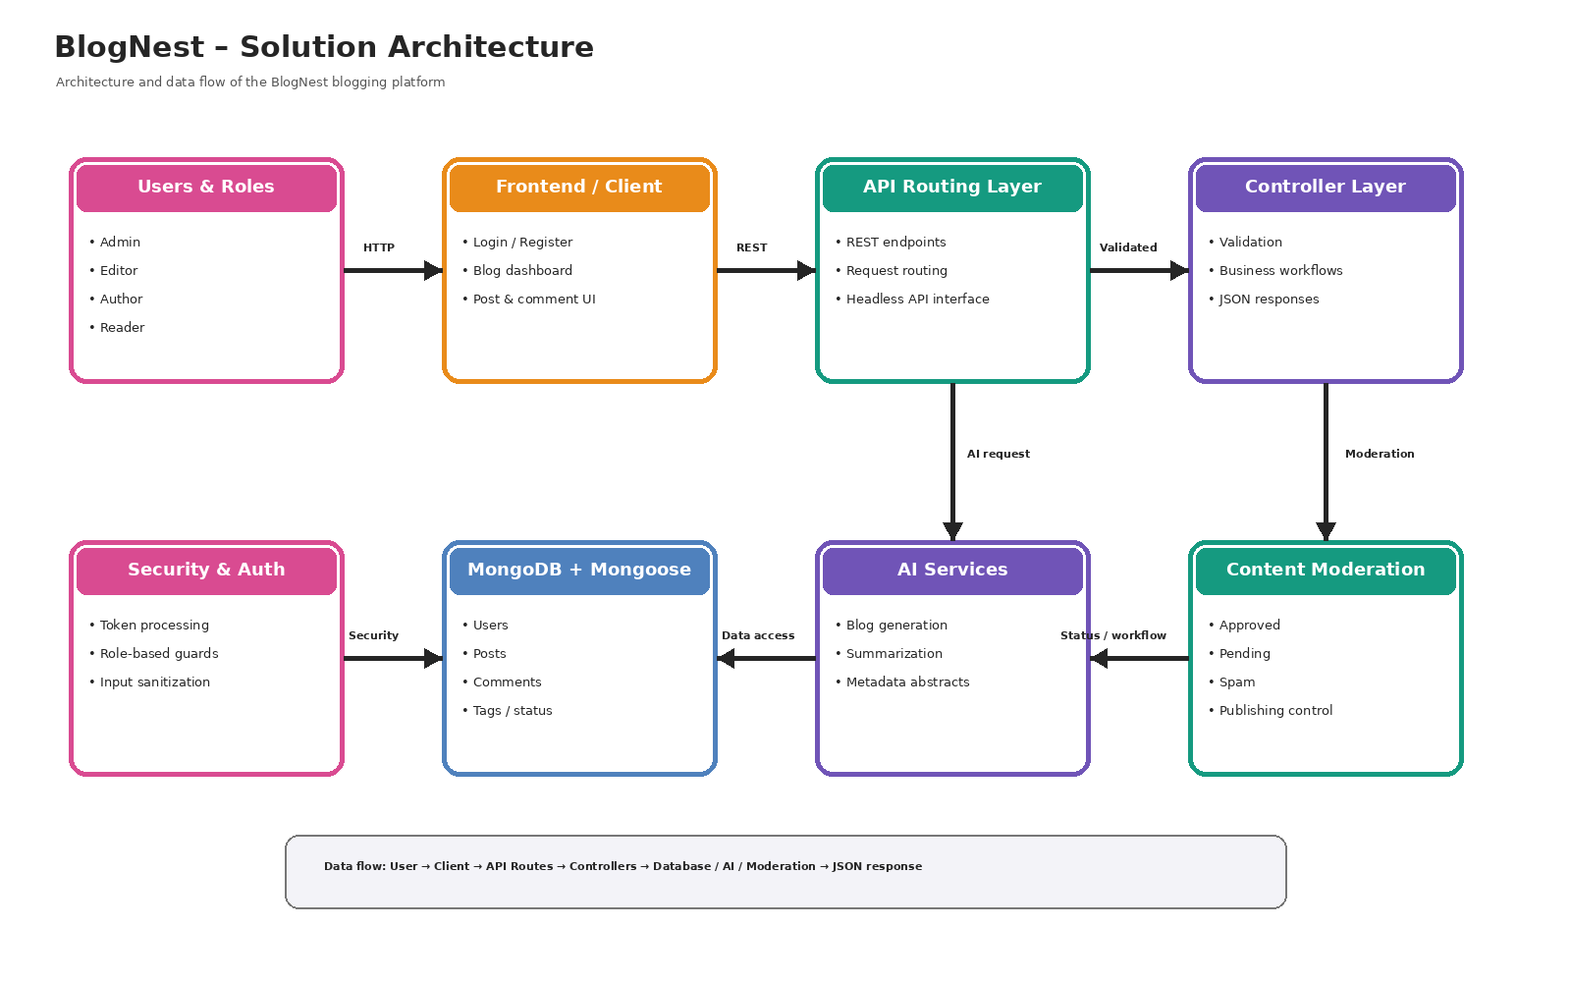

Architecture and Data Flow
1. Users access BlogNest through the client interface according to their assigned role.
2. Client requests are sent to the API Routing Layer through REST endpoints.
3. The Controller Layer validates requests and executes the required business workflow.
4. Security controls process authentication tokens, role permissions and unsafe input.
5. Mongoose models provide access to MongoDB for users, posts, comments, tags and status information.
6. AI Services can generate blog content or create summaries, abstracts and metadata from the requested content.
7. Content Moderation manages comment states such as approved, pending and spam and supports controlled publishing.
8. The processed result is returned to the client as a structured JSON response.

Technology and Design Characteristics
- Backend follows an MVC-oriented structure with Mongoose models and controller-based request processing.
- The View layer is represented by a headless API Routing Layer rather than traditional server-rendered templates.
- Role-based route guarding limits operations according to Admin, Editor, Author and Reader responsibilities.
- CRUD operations support the complete lifecycle of blog posts.
- Input sanitization is included to reduce XSS and unsafe NoSQL-style parameter manipulation risks.
- AI functions are separated as services so generation and summarization can be extended independently.

Expected Benefits
The architecture provides a modular structure in which content management, authentication, security, data storage, moderation and AI functions are connected but logically separated. This makes the BlogNest system easier to understand, develop, maintain and extend.

Reference
Architecture structure adapted to the provided Solution Architecture template and the documented BlogNest project design.

